Introduction to week7

# LSTM + LSTM, 2 hidden layers

This week, we continue to use the model of 2 hidden layers: LSTM + LSTM, the code:

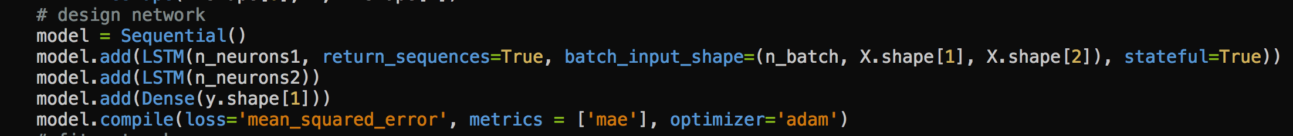

# Repair data

During the previous weeks, I didn’t change any of the given data. I found that there were some duplicated and missed data. For example, several days’ data were duplicated, the dates of the missing data are:

1. 2017-02-04
2. 2017-02-05
3. 2017-07-14
4. 2017-07-15
5. 2017-07-16
6. 2017-07-30
7. 2017-09-14
8. 2017-10-02
9. 2017-10-08
10. 2017-11-03

I think that the exact day in a week has significant influence to the result of forecast, and thus keeping the 7-day cycle in the original data would be very important. This week I tried to add missing data and remove duplicated to keep the 7-day’s rhythm.

I added the missing data by using the average of the previous and next day’s data. I also changed the outlier data to the average of the previous and next day’s data.

# Choose validation data

After pre-processing missed and duplicated data, there were 520 lines of data (4 more lines than the original data). The corresponding validation dataset would be:



# Make a forecast

Next, I selected three validation data (start from day 409, 437, and 465), got the model whose hidden layers’ neurons are 12 and 4 (two LSTM hidden layers).

Then I used the whole training data, and make a 600-epochs’ train, and then made a 30-turns’ forecast, the results of RMSE are shown as following:



The results of MAPE are shown as following:



If we plot the first 7-day’s forecast data:



It could be noticed that, all the peaks are captured!